RESOLUTION NO.__________

RE: CERTIFICATE OF APPROPRIATENESS UNDER THE
PROVISIONS OF THE ACT OF THE PENNSYLVANIA
LEGISLATURE 1961, JUNE 13, P.L. 282 (53
SECTION 8004) AND BETHLEHEM ORDINANCE NO.
3952 AS AMENDED.

WHEREAS, it is proposed to replace the door and modify the exterior for ADA compliance at 29 E. Third Street,

NOW, THEREFORE, BE IT RESOLVED by the Council of the City of Bethlehem that a Certificate of Appropriateness is hereby granted for the work.

Sponsored by: (s)

(s)

ADOPTED BY COUNCIL THIS DAY OF

(s)
President of Council

ATTEST:

(s)
City Clerk

HISTORIC CONSERVATION COMMISSION

CASE # 554 – It is proposed to replace the door and modify the exterior for ADA compliance at 29 E. Third Street
OWNER/APPLICANT: Bank of America / Project Expediters Consulting Corp

The Commission upon motion by Mr. Roeder seconded by Mr. Lader adopted the proposal that City Council issue a Certificate of Appropriateness for the proposed work described herein:
- The proposal to replace the door and modify the exterior for ADA compliance at 29 E. Third Street was presented by Jacqueline Menges.
- The new door will be almost centered with 2 side lights in clear anodized aluminum frames. The door will have 5” stiles and top rail, and the bottom rail will be 10” to meet code.
- A kynar paint finish is highly recommended to match the new paint color used on the arched window above the door and all the other windows in the building.
- The proposed motion was unanimously approved.

CU: cu
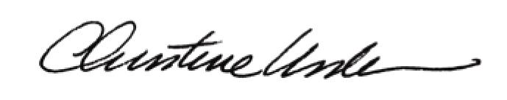

By:

Date of Meeting: June 15, 2015 Title: Historic Officer

